<Online Clothing>

Object Design Document

<01.01.2017>

<Sedat Aysal>

<Tahir Onural Tekizbaş>

<Sahra Nur Gürel >

Prepared for

SE301 Software Engineering



Table of Contents

1. Introduction 1

1.1. Object Design Trade-offs 1

1.2. Interface Documentation Guidelines 1

1.3. Definitions, Acronyms, and Abbreviations 1

1.4. References 1

2. Packages 1

3. Class Interfaces 1

OBJECT DESIGN DOCUMENT

# Introduction

## Object Design Trade-offs

The project name is Online Clothing system. This web site is about buying product from a web site.The purpose of the document is describe design and architecture of the “Online Clothing ” site. All code in this system is our own original work. Incuding data and user interfaces. We use the database to keep information. Database system that we used named phpmyadmin. Our objective of the system is basic but there are every details and function used by Online Clothing system. Therefore, database increase security in system. System keep some information like password and username securely.

## Interface Documentation Guidelines

In this system object design principle had applied. There are two groups of graphical design in this project. First graphical design was made for User side and the other was made for admin side. User panel has also two groups user and visitor. These two designs are similar to each other.

On the visitor side , there are some criterias. For example; visitor can only display product and search for product. These system is easy and understandable for visitor if he or she wants to buy a product, he or she must register. The user side is after registration , he or she can display product , add product, give orders.

The Admin panel is more complex than user and visitor side. But also easy to use for an admin. Menus are clearly identified on the panel. Admin can check all users , add user, delete user and do the same operations for manager. These are some examples for admin side.

## Definitions, Acronyms, and Abbreviations

Database : It is a collection of information that is organized so that it can easily be accessed.

ID : Identification

ODD : Object Design Document

UI : User Interface

Server : It is a computer provides services to other computers.

Exception : Represents errors that occur during application execution

## References

http://searchsqlserver.techtarget.com/definition/database

<http://dioscuri.sourceforge.net/docs/ODD_Dioscuri_KBNA_v1_1_en.pdf>

# Packages

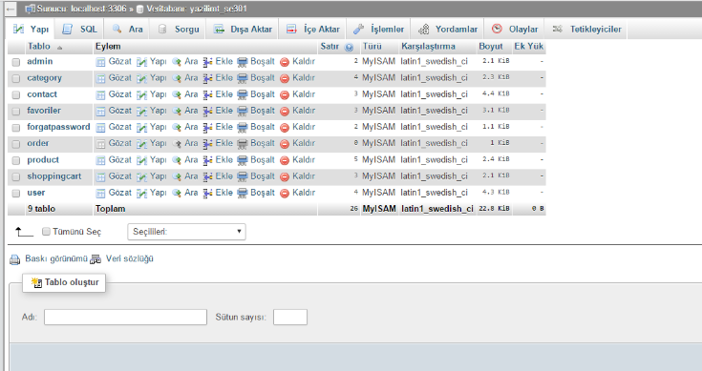

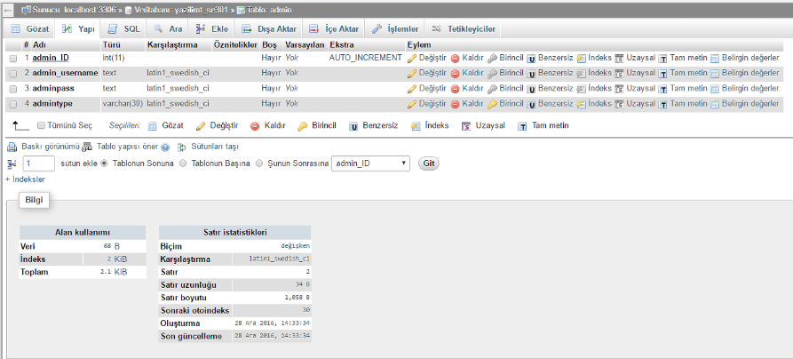

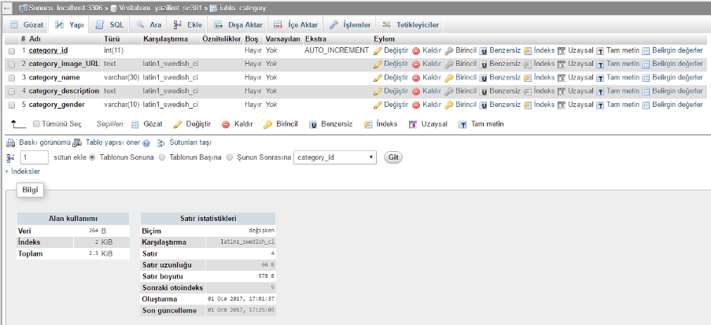

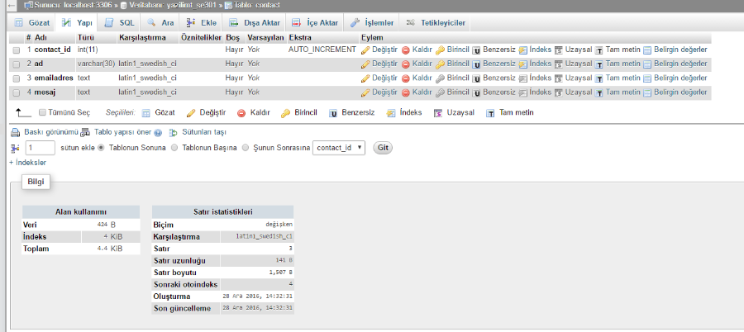

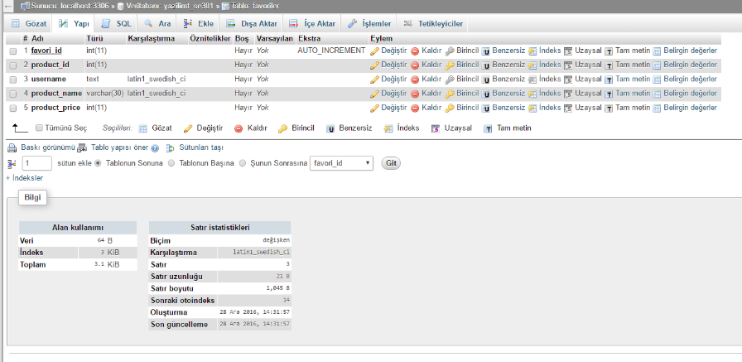

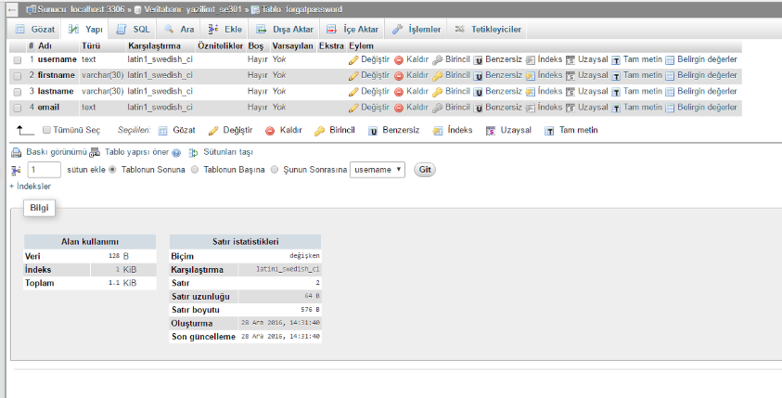

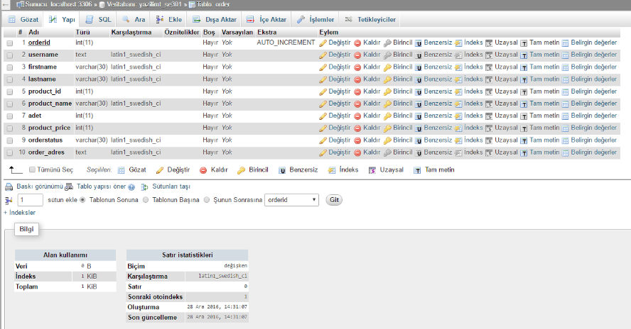

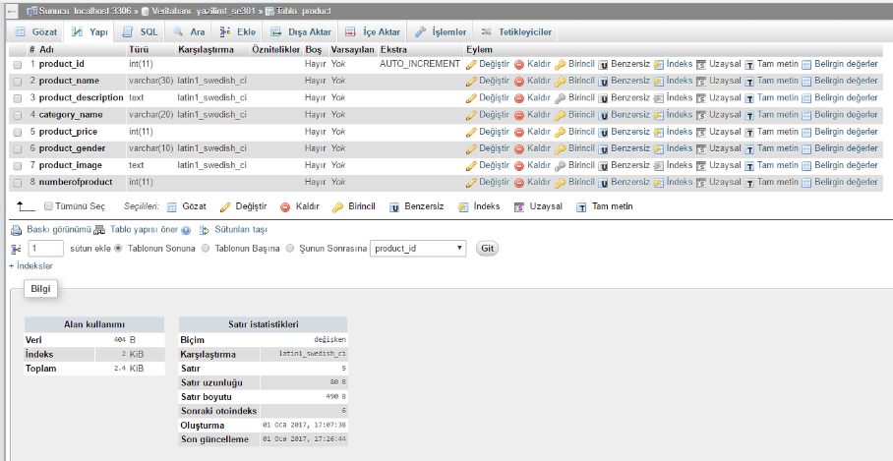

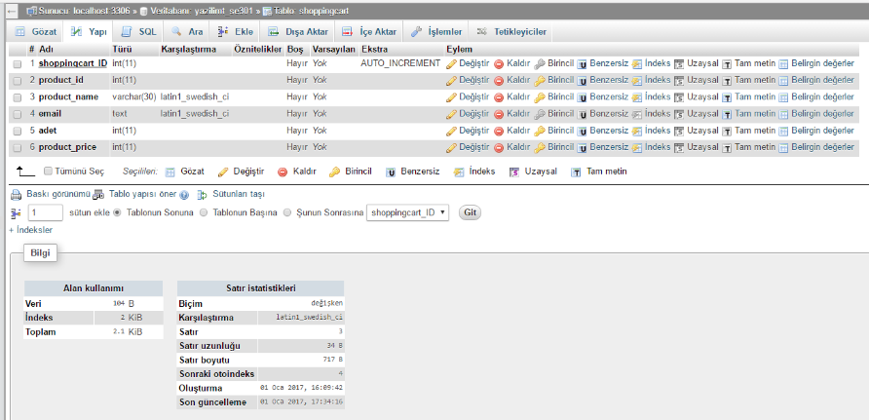

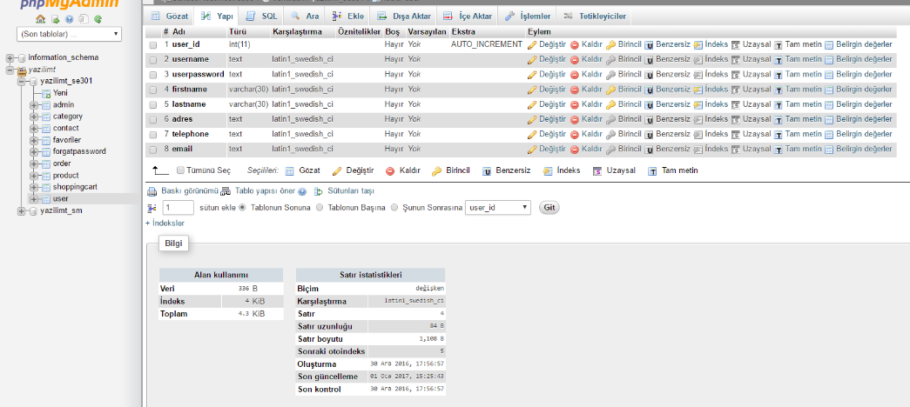

# Class Interfaces

**3.1.1 User**

This class explains and shows the content about user functions.

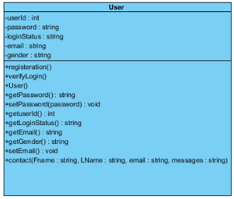

**3.1.2 Registration**

This class explains and shows the content about registration functions.

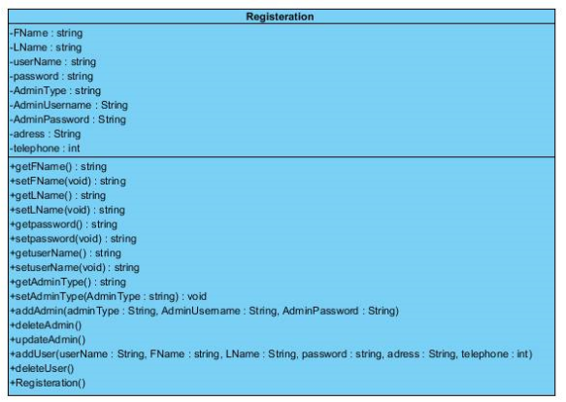

**3.1.3 Order**

This class explains and shows the content about order functions.

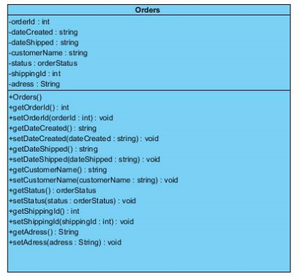

**3.1.4 Category**

This class explains and shows the content about category functions.

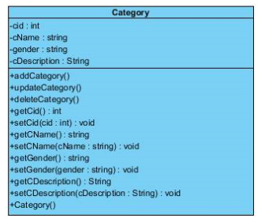

**3.1.4 Product**

This class explains and shows the content about product functions.

